# Webservice 1 : Transformation to HTML:

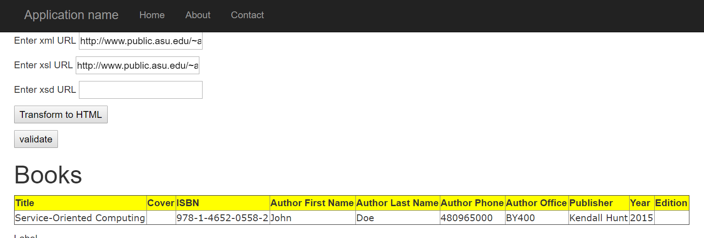

# Webservice 2: Validation

## First: With No Errors:

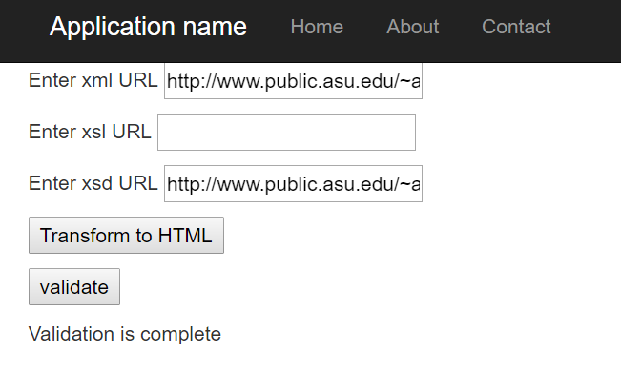

## Second: With Errors:

